Searching a sequence databank :

Question 1:

>Sequence1
ATGCAAATCTACAACGTAGTCGTCACGGCCCACGCTTTCGTCATAATCTTCTTCATAGTCATGCCAATTA
TGATCGGTGGATTCGGAAACTGACTAGTCCCCCTAATAATTGGGGCCCCAGACATAGCATTCCCCCGAAT
AAACAACATGAGCTTCTGACTCCTACCCCCATCCTTCCTCCTACTACTTGCCTCATCCACAGTTGAAGCA
GGAGCAGGAACAGGATGAACAGTCTACCCTCCCCTAGCCGGCAATCTAGCCCACGCCGGAGCATCAGTAG
ATCTAGCCATCTTCTCCCTTCACTTGGCAGGTATCTCCTCAATCCTAGGGGCAATTAACTTCATCACAAC
CGCAATCAACATAAAACCCCCTGCCCTCTCGCAATACCAAACACCCCTATTCGTCTGATCCGTACTAATC
ACTGCAGTCCTCCTCCTCCTATCTCTTCCAGTACTCGCCGCAGGCATCACCATGCTTCTCACTGACCGCA
ACCTCAACACCACTTTCTTTGACCCGGCAGGAGGGGGAGACCCAGTGCTCTACCAACACCTCTT

This sequence is most likely Cyanistes caeruleus voucher S15 cytochrome c oxidase subunit I (COX1) gene, partial cds; mitochondrial found in Cyanistes caruleus (blue tits).

NB: The database shows that the poorest corresponding sequence is still a 99% match. All genes come from blue tits so we can be pretty sure that this is the corresponding organism. The natural next step is to look at the ORF to identify the right sequence from all these possibilities.

Generating an ORF (Open Reading Frame) Map:

Question 2:

AN open reading frame refers to a reading frame that contains a START codon and extend without encountering a STOP codon. If the distance between the START and STOP codon is long enough, the sequence may be corresponding to a protein coding gene.

Question 3 and 4:

>GQ481669.Eurasian_blue_tit 1:101-654 Cyanistes caeruleus voucher ZMMU MVK 477 cytochrome oxidase subunit 1 (COI) gene, partial cds; mitochondrial
GACCAAATCTACAACGTAGTCGTCACGGCCCACGCTTTCGTCATAATCTTCTTCATAGTCATGCCAATTATGATCGGTGG
ATTCGGAAACTGACTAGTCCCCCTAATAATTGGAGCCCCAGACATAGCATTCCCCCGAATAAACAACATGAGCTTCTGAC
TCCTACCCCCATCCTTCCTCCTACTACTTGCCTCATCCACAGTTGAAGCAGGAGCAGGAACAGGATGAACAGTCTACCCT
CCCTTAGCCGGCAATCTAGCCCACGCCGGAGCATCAGTAGATCTAGCCATCTTCTCCCTTCACTTGGCAGGTATCTCCTC
AATCCTAGGGGCAATTAACTTCATCACAACCGCAATCAACATAAAACCCCCTGCCCTCTCGCAATACCAAACACCCCTAT
TCGTCTGATCCGTACTAATCACTGCAGTCCTCCTCCTCCTATCTCTTCCAGTACTCGCCGCAGGCATTACCATGCTTCTC
ACTGACCGCAACCTCAACACCACTTTCTTTGACCCGGCAGGAGGGGGAGACCCAGTGCTCTACCAACACCTCTT

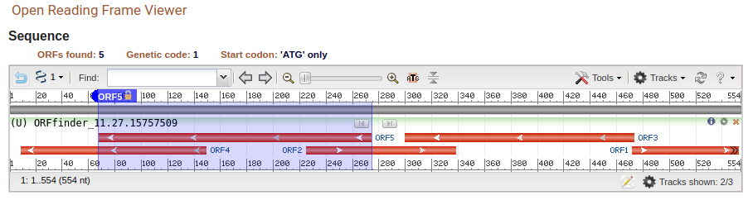

The longest ORF is ORF5 one with length 207 bp.

When you run this sequence in the ORF finder using the vertebrate mitochondrial genetic code, we get a single long ORF which leeds us to think that this is the right reading frame. This is therefore more likely to be a mitochondrial sequence.

>lcl|ORF1
MPIMIGGFGNWLVPLMIGAPDMAFPRMNNMSFWLLPPSFLLLLASSTVEAGAGTGWTVYPPLAGNLAHAGASVDLAIFSLHLAGISSILGAINFITTAINMKPPALSQYQTPLFVWSVLITAVLLLLSLPVLAAGITMLLTDRNLNTTFFDPAGGGDPVLYQHL

Question 5:
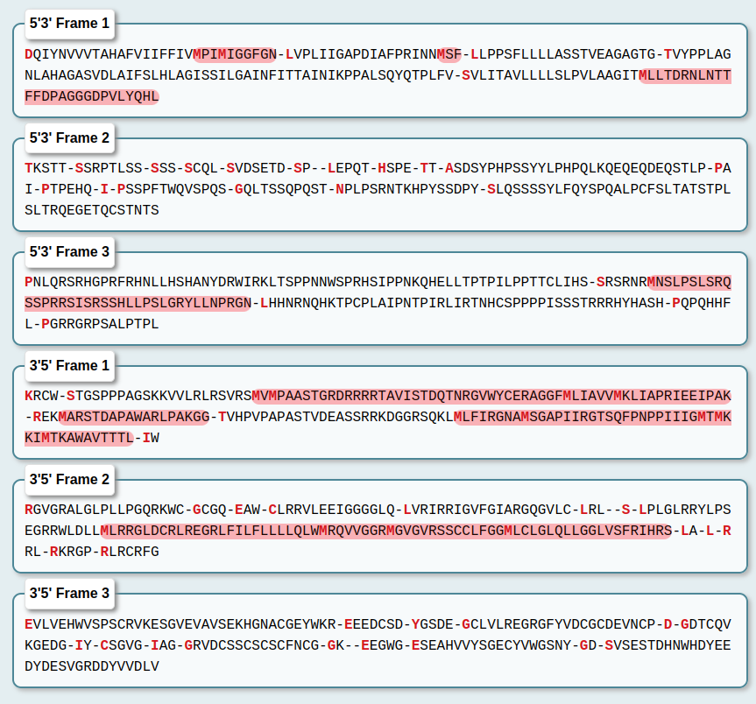
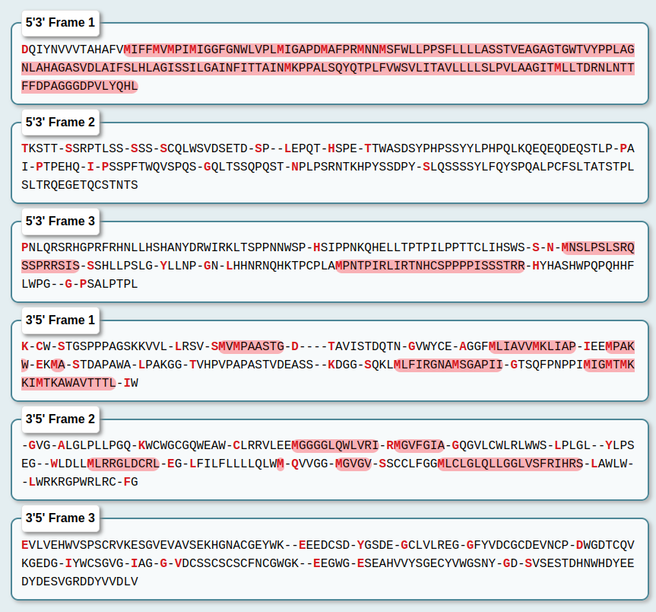
What we can see is that when we use the vertebrate mitochondrial code (left), we again get longer corresponding ORF with regards to the stadard gentic code (right). This backs up your analysis from ORFfinder.

I in standard code = M in vertebrate mitochondrial genetic code

The corresponding seauence under FASTA format is:
> VIRT-3213135:5'3' Frame 1, start_pos=14
MIFFMVMPIMIGGFGNWLVPLMIGAPDMAFPRMNNMSFWLLPPSFLLLLASSTVEAGAGTGWTVYPPLAGNLAHAGASVDLAIFSLHLAGISSILGAINFITTAINMKPPALSQYQTPLFVWSVLITAVLLLLSLPVLAAGITMLLTDRNLNTTFFDPAGGGDPVLYQHL

Searching Sequence Databanks continued:

Question 6:

The scores and e (expect)-values of the closest match are 323 and 6e-109

NB: The percentage identity is not the most important indicator here.

Question 7:

The closest match

Scroll down the screen to see how similar the input sequence is to (i) the closest match (ii) to the 8th closest match (in Saccharomyces). Click on the 8th closest match and it will show you the alignment. Write down the percentage similarities of these matches across the aligned region. What do the + symbols between the sequences represent?

Question 8: In question 5 above you wrote down the e-value of two of the matching sequences. What does the e (expect) value represent? Using this knowledge and the descriptions of the matching sequences what do you think is the first ‘random’ (i.e. nonhomologous) sequence in the ‘Sequences producing significant alignments’ list? THINK 4 about this and then justify your answer. (Knowing when a match is significant and when it is not is often important). What is the range of species that the protein is present within?

